 | 14.1.9 Editors - Video Sequence Editor - Header - Strip Menu
Table of content
Strip menu in Sequencer window 3
Transform - Submenu 3
Move 3
Last operator Sequence Slide 4
Offset X 4
Y 4
Move/Extend from Frame 4
Last operator Transform 4
Values X, Y, Z, W 4
Axis 4
Orientation 4
Proportional editing 4
Slip strip content 4
Snap Strips to the current frame 4
Clear Strip Offset 4
Swap Strip Left 4
Swap Strip Right 4
Remove Gaps 5
Last operator Remove Gaps 5
All Gaps 5
Insert Gaps 5
Last operator Remove Gaps 5
Frames 5
Retiming - Submenu 5
Enable/Disable Retiming 5
Set Speed 6
Speed 6
Preserve Current Retiming 6
Add Retiming Key 6
Last operator Add Retiming Key 6
Timeline Frame 6
Add Freezeframe 6
Last operator Add Freeze Frame 6
Duration 6
Reset Timing 6
Add Speed Transition 6
Last operator Add Speed Transition 7
Duration 7
Split 7
Last operator Split Strips 7
Frame 7
Channel 7
Type 7
Use Cursor Position 7
Side 7
Hold Split 7
Last operator Split Strips 8
Frame 8
Channel 8
Type 8
Use Cursor Position 8
Side 8
Copy 8
Paste 8
Duplicate Strips 8
Last operator Duplicate Strips 8
Offset X 8
Y 8
Delete 8
Delete Strip & Data 9
Change Operators 9
Change Scene 9
Change Effect Input 9
Change Effect Type 9
Path/Files 9
Add Modifier – Submenu 9
Copy modifiers to selection 10
Movie Strip - Submenu 10
Set Render Size 10
Deinterlace Movies 10
Effect Strip 10
Reassign Inputs 10
Swap Inputs 10
Set Render Size 10
Separate Images 11
Last Operator Separate Images 11
Make Meta Strip 11
UnMeta Strip 11
Toggle Meta 11
Set Color Tag 11
Lock/Mute - Submenu 11
Lock Strips 11
Unlock Strips 11
Mute Strips 11
Last operator Mute Strips 12
Unselected 12
Unmute Strips 12
Last operator Unmute Strips 12
Unselected 12
Mute unselected strips 12
Last operator Mute Strips 12
Unselected 12
Unmute deselected Strips 12
Last operator Unmute Strips 12
Unselected 12
Inputs - Submenu 12
Reload Strips 12
Reload Strips and Adjust Length 12
Change Paths/Files 12
Swap Data 13
Strip menu in Preview window 13
Transform - Submenu 13
Move 13
Rotate 13
Scale 13
Delete 13
Delete Strip & Data 13
Update Scene Frame Range 13
Change - Submenu 13

Strip menu in Sequencer window
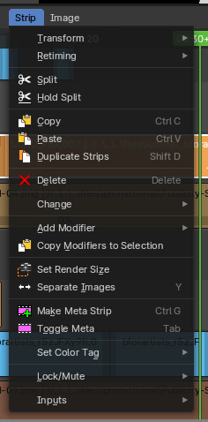
The strip menu contains strip related functionality. The content differs, dependent of the selected strip.

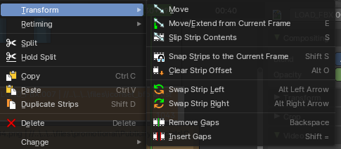
Transform - Submenu
This sub-menu contains transform operators that you can use on strips.

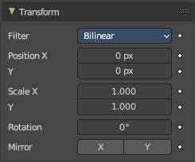
Move
Moves the selected strip(s).

Last operator Sequence Slide

Offset X
The horizontal frame offset from the starting position.

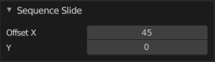
Y
The vertical offset from the starting channel.

Move/Extend from Frame
Extends the selected strips relative to the frame indicator and the mouse position. All selected strip handles to the mouse side of the current frame indicator will transform together.

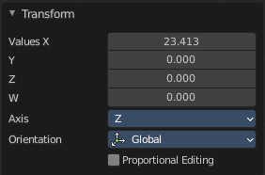
Last operator Transform

Values X, Y, Z, W
The transform values, relative to the starting point.

Axis
The transform axis orientation. This axis value box has no meaning here.

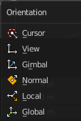
Orientation
Choose the type of orientation for the transform action.

Proportional editing
The tool has no proportional editing. The checkbox cannot be activated.

Slip strip content
Change the position of the contents of a strip without moving the strip itself.

Snap Strips to the current frame
Snaps the selected strips to the current frame.

Clear Strip Offset
Clear strip offset from the start and end frames.

Swap Strip Left
Swap the active strip with the strip to the left.

Swap Strip Right
Swap the active strip with the strip to the right.

Remove Gaps
Removes gaps at the frame indicator position in the current channel. Strips after the indicator will move to the left to close the gap.

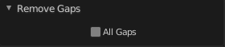
Last operator Remove Gaps

All Gaps
Remove all gaps between all clips at the right side.

Insert Gaps
Inserts a gap at the frame indicator position. Strips after the indicator will move to the right by the amount of gap frames.

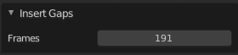
Last operator Remove Gaps

Frames
The size of the gap in frames.

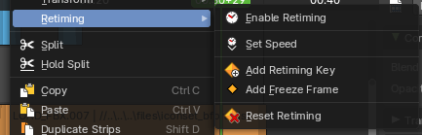
Retiming - Submenu
This submenu contains retiming operators to help change the speed of movie strips. This menu is context sensitive. If you select a retiming keyframe, you will see a new set of operators.
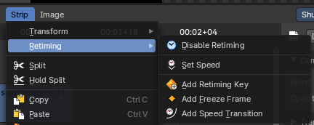

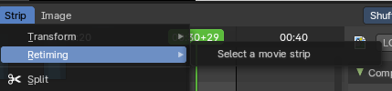
Note: These operators only work on movie strips, and you must have one selected to see the operators.

Enable/Disable Retiming
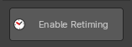
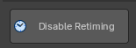
Enables and Disables the retiming keys of a strip. When you enable retiming, you will be able to set keyframes to retime at difference speeds, to set freeze frames, and or set gradient time changes between keyframes.

Set Speed
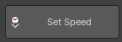
Sets the speed of a retimed segment. If there is no segment, it will create a new segment. To edit the segment, Enable Retiming.
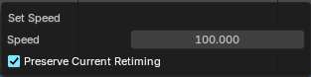
Note: The speed is a percentage of total, where 100% is original speed, 110% of the movie playback is 10% faster, and at 90% the movie playback is 10% slower.

Speed
The new speed value.

Preserve Current Retiming
With preserve current retiming the strip changes length instead of changing next segment speed.

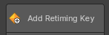
Add Retiming Key
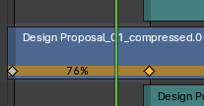
Adds a retiming key. Here you can change strip speeds in various locations within the strip to squash and stretch time dynamically. To edit a retiming key, click on it in the bottom row of the movie strip and drag left or right. A percentage overlay will show the amount of time change is happening between the keyframes.

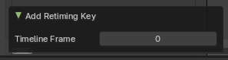
Last operator Add Retiming Key

Timeline Frame
Defines which frame the new retiming keyframe is placed.

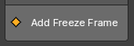
Add Freezeframe
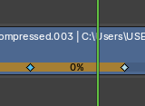
Adds a freeze frame by creating two retiming keyframes with 0% time change between them. You can then later adjust the length of the freezeframe by adjusting either of the retiming keyframes.

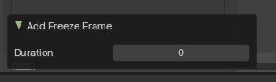
Last operator Add Freeze Frame

Duration
Defines the duration of the freeze frame.

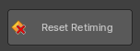
Reset Timing
Resets the movie strip to original playback speed.

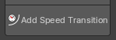
Add Speed Transition
Add a smooth time transition between two retimed segments.
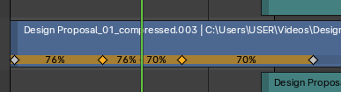
To do this, create 3 retiming keyframes, select the middle one, then use the operator. This will create two new keyframes with a begging percentage and an ending percentage. The distance between these two retiming keyframes will be the duration of the transition.
Note: This operator only shows when you have a retiming keyframe selected.

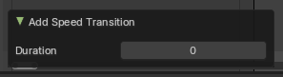
Last operator Add Speed Transition

Duration
Defines the duration of the Speed Transition between the two new retiming keyframes.

Split
Split the selected strip into two parts at the current frame.

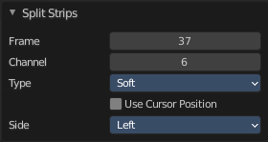
Last operator Split Strips

Frame
The frame at which the cut happens.

Channel
The channel of the strip.

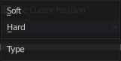
Type
How to cut. Soft or hard.

Use Cursor Position
Split at the position of the cursor instead of the current frame. Note! This setting makes no sense. You can't adjust the cursor position afterwards.

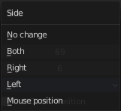
Side
The side that remains selected after the split.

Hold Split
Like Split, it splits a strip in two strips. But you will not be able to drag the endpoints to show the frames past the split of each resulting strip. You can adjust the Hold Offset number fields in the Strip Info panel.

Last operator Split Strips

Frame
The frame at which the cut happens.

Channel
The channel of the strip.

Type
How to cut. Soft or hard.

Use Cursor Position
Split at the position of the cursor instead of the current frame. Note! This setting makes no sense. You can't adjust the cursor position afterwards.

Side
The side that remains selected after the split.

Copy
Copies the selected strip(s).

Paste
Pastes copied strip(s).

Duplicate Strips
Duplicates the selected strip(s).

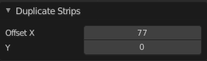
Last operator Duplicate Strips

Offset X
The horizontal frame offset from the starting position.

Y
The vertical offset from the starting channel.

Delete
Deletes the selected strip(s).

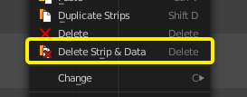
Delete Strip & Data
Deletes the selected scene strip types and associated scene data.
This will then convert the associated scene to an orphan data block which will be permanently removed upon save and re-load of the *.blend file.

Change Operators
These operators show and hide depending on the strip selection context.
If a strip cannot be changed, it will advise you to selected a changeable strip, which are Scene, Effect and Data strips.

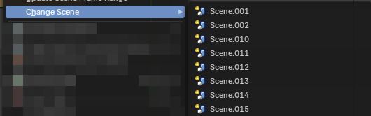
Change Scene
Changes a scene strip with another scene. Only shows when a scene strip is selected. If there are fewer than 14 scenes, it will list all scenes you could change to. If more than 14 scenes, it will call a search dialogue.

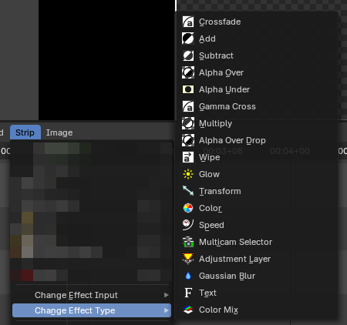
Change Effect Input
Changes a selected existing effect strip input order. Only shows when an effect strip is selected.

Change Effect Type
Changes a selected existing effect strip effect type. Only shows when an effect strip is selected.

Path/Files

Changes a selected existing strip path/file. Only shows when a data strip is selected. Audio, Movie and Image/Sequence strip are data strips.

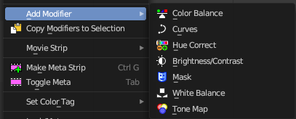
Add Modifier – Submenu
All strip types. Adds a strip modifier. Strip modifiers are explained in the sidebar chapters.
Sound strips has different content in the modifier menu.

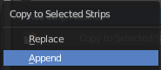
Copy modifiers to selection
Copies the modifiers from the source strip to the target strip by given method. It opens a popup where you can choose the method.
First select the source strip. Hold down shift, select the second strip. Perform the tool.

Movie Strip - Submenu
Strip type Movie.

Set Render Size
Set the render size and aspect from the active strip. Attention, there is no feedback if the operation was successful. It simply sets it.

Deinterlace Movies
Deinterlaces the selected movie strips.

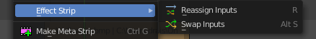
Effect Strip
Strip type Effects.

Reassign Inputs
Reassigns the input of the strips.
Unfortunately not to find out how this works.

Swap Inputs
Swaps the inputs of the selected strips.
Unfortunately not to find out how this works.

Set Render Size
Strip type Image. Set the render size and aspect from the active image strip. Attention, there is no feedback if the operation was successful. It simply sets it.

Separate Images
Strip type Image. Create a strip for every image in the image sequence strip.

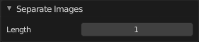
Last Operator Separate Images
The length of each frame of the new created strips.

Make Meta Strip
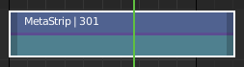
Creates a meta strip out of the selected strips. A Meta Strip is a strip which contain multiple strips treated as if it was one strip. It allows you to reduce the vertical space used in the Sequencer. You can edit it the same way as any other strips.
Note! The default blend mode for a Meta strip is Replace. There are many cases where this alters the results of the animation so be sure to check the results and adjust the blend mode if necessary.

UnMeta Strip
Separating (ungrouping) the Meta strip restores the strips to their relative positions and channels.

Toggle Meta
Toggles between the meta and unmeta state. You need to have a meta strip in the sequencer timeline already.

Set Color Tag
Set the display color of the strips.

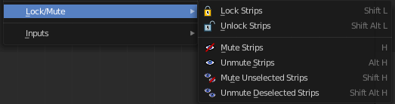
Lock/Mute - Submenu

Lock Strips
Locks the strip from editing. They can't be moved or edited anymore.

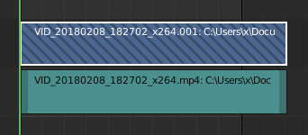
Locked strips appears hatched.

Unlock Strips
Unlock locked strips.

Mute Strips
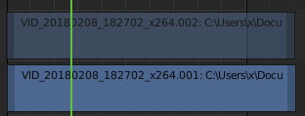
Mutes the selected strips. They do not play anymore, and they appear greyed out.

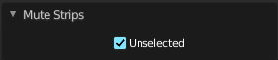
Last operator Mute Strips

Unselected
Mute unselected strips.

Unmute Strips
Unmutes selected muted strip.

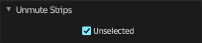
Last operator Unmute Strips

Unselected
Unmute unselected strips.

Mute unselected strips
Mute the unselected strips.

Last operator Mute Strips

Unselected
Mute unselected strips.

Unmute deselected Strips
Unmute all deselected strips.

Last operator Unmute Strips

Unselected
Unmute unselected strips.

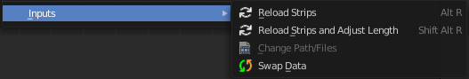
Inputs - Submenu

Reload Strips
Reloads the strips in the sequencer.

Reload Strips and Adjust Length
Reloads the strips in the sequencer.

Change Paths/Files
Undocumented Operator. Opens a file selector.

Swap Data
Swaps the data between two selected strips. The strips must be compatible.

Strip menu in Preview window
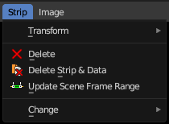
The strip menu contains strip related functionality.

Transform - Submenu

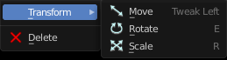
Move
Move the selected item.

Rotate
Rotate the selected item.

Scale
Scale the selected item.

Delete
Delete the selected item.

Delete Strip & Data
Deletes the selected item and all of its data.

Update Scene Frame Range
Shows with a scene strip. Update the frame range of the scene strip.

Change - Submenu
Allows you to change things like the source scene. Or the effect of a effect strip.

